
SRM Institute of Science and Technology
Mode of Exam
OFFLINE
College of Engineering and Technology
School of Computing
DEPARTMENT OF COMPUTING TECHNOLOGIES
SRM Nagar, Kattankulathur – 603203, Chengalpattu District, Tamilnadu
Academic Year: 2023-2024 (ODD)
Test: CLAT-2 Date: 07-10-2023
Course Code & Title: 18CSE458T – Wireless and Mobile Communication Duration: 100 Minutes
Year & Sem: IV Year – VII Semester Max. Marks: 50

Course Articulation Matrix: (to be placed)

Part - A
( 10 x 1 = 10 Marks)
Instructions: Answer all
Q. No | Question | Marks | BL | CO | PO | PI Code
1 | Select the Incorrect statement about TDMA from the following options  - High transmission rate  - Discontinuous data transmission  - Single carrier frequency for single user  - No requirement of duplexers | 1 | 1 | 2 | 3 | 1.6.1
2 | The guard interval is provided in OFDM  a. To eliminate the need of pulse shaping filter  b. To eliminate ISI  c. High symbol rate  d. Both a) and b) | 1 | 1 | 2 | 3 | 1.6.1
3 | In Aloha technique, the re-transmission takes place immediately.  a) True  b) False | 1 | 1 | 2 | 3 | 1.6.1
4 | Which of the following is not true for TDMA?  a) Single carrier frequency for single user  b) Discontinuous data transmission  c) No requirement of duplexers  d) High transmission rates | 1 | 1 | 2 | 3 | 1.6.1
5 | The bandwidth of FDMA channel is ______  a) Wide  b) Narrow  c) Large  d) Zero | 1 | 1 | 2 | 3 | 1.6.1
6 | Which of the following is the MSC that acts as a bridge between the cellular network and other networks?  - Home location register (HLR)  - Visitor location Register (VLR)  - Gateway MSC  - Authentication centre (AuC) | 1 | 1 | 3 | 3 | 1.6.1
7 | How many minimum satellites are operational in the constellation of GPS?  - 24  - 25  - 26  - 27 | 1 | 1 | 3 | 3 | 1.6.1
8 | What is the Access technique used by an LTE or LTE-A network?  A) WCDMA  B) FDMA  C) PDMA  D) OFDMA | 1 | 1 | 3 | 3 | 1.6.1
9 | WiMax provides up to ___ range of speed for a fixed station?  - 1GB/s  - 2Gb/s  - 3Gb/s  - 4Gb/s | 1 | 1 | 3 | 3 | 1.6.1
10 | GPS satellites are  A. GEO  B. MEO  C.LEO  D.none of the above | 1 | 1 | 3 | 3 | 1.6.1
Part – B
( 5 x 2 = 10 Marks)
Instructions: Answer all
6 | Compare cell splitting and cell sectoring in detail | 2 | 1 | 2 | 3 | 1.6.1
7 | List the advantage s and disadvantages of CDMA | 2 | 1 | 2 | 3 | 1.6.1
8 | Explain the advantages of cellular systems with small cells | 2 | 2 | 2 | 3 | 1.6.1
9 | Define GPRS and list out the benefits of GPRS | 2 | 2 | 3 | 3 | 1.6.1
10 | Classify LTE and WiMax | 2 | 3 | 3 | 3 | 1.6.1
Part – B
( 2 x 15 = 30 Marks)
Instructions: Answer all
11 a  11 b | Illustrate frequency division multiple access and time division multiple access with neat sketch.  (Or)  Describe Code division multiple Access in detail with neat sketch | 15 | 2 | 2 | 3 | 1.6.1
12 a  12 b | Illustrate GSM System Architecture, elements and interfaces in detail  (or)  Explain 4G Cellular Systems with its types in details | 15 | 3 | 3 | 3 | 1.6.1

*Performance Indicators are available separately for Computer Science and Engineering in AICTE examination reforms policy.

Course Outcome (CO) and Bloom’s level (BL) Coverage in Questions

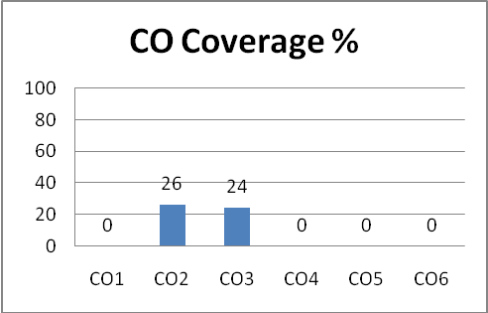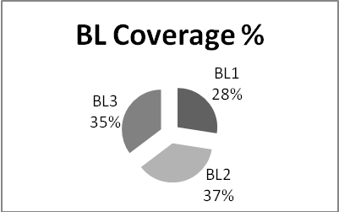

Approved by the Audit Professor/Course Coordinator

